**Decimal to Binary**

Given a decimal number as input, we need to write a program to convert the given decimal number into an equivalent binary number.

**Examples:**

Input : 7

Output : 111

Input : 10

Output : 1010

Input: 33

Output: 100001

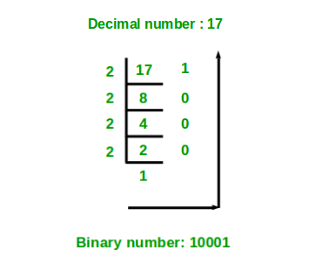

C++

#include<iostream>

#include<vector>

using namespace std;

int main()

{

int n;

cin >> n;

vector<bool>v;

while(n > 0)

{

int t = n % 2;

v.push_back(t);

n /= 2;

}

for(int i = v.size() - 1; i >= 0; i--)

cout << v[i];

return 0;

}

**INPUT :**

**5**

**OUTPUT :**

**101**